***RPG Game Manual***

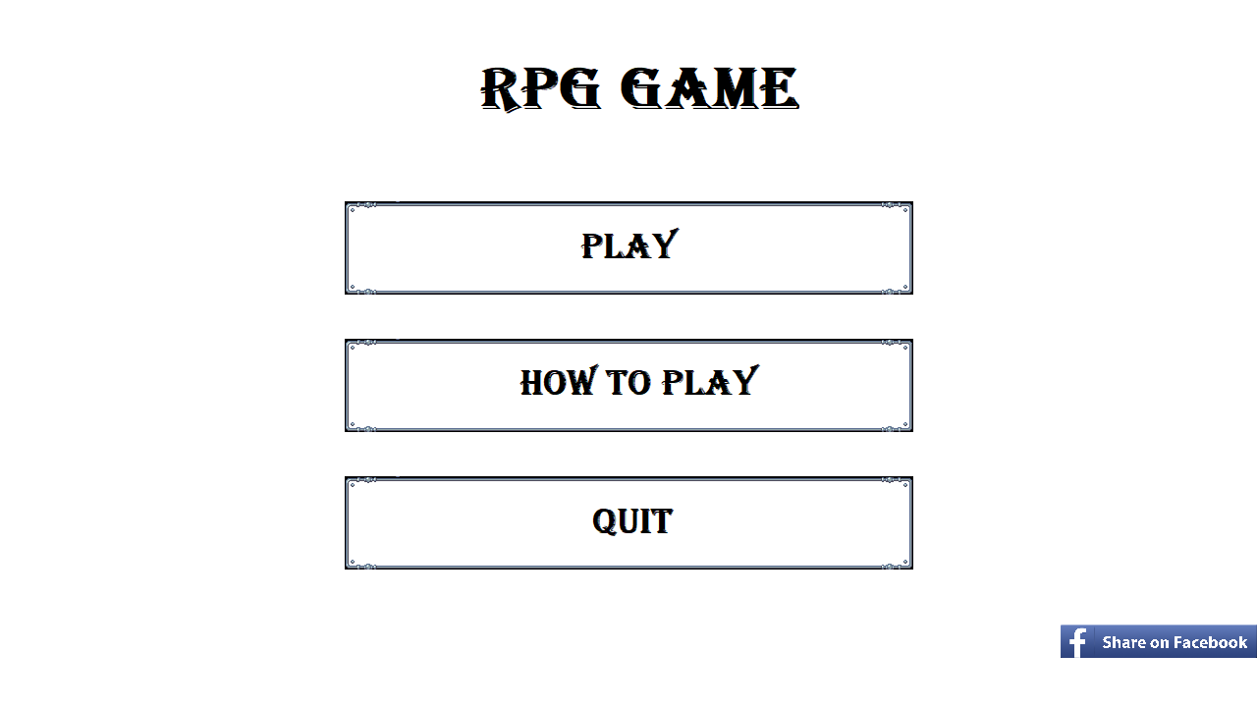

***Use the mouse to select the buttons here***

***Play – To Play The Game***

***How To Play – Shows you how to play***

***Share on Facebook – Share on FaceBook that you are playing***

***Quit- Quit The Game***

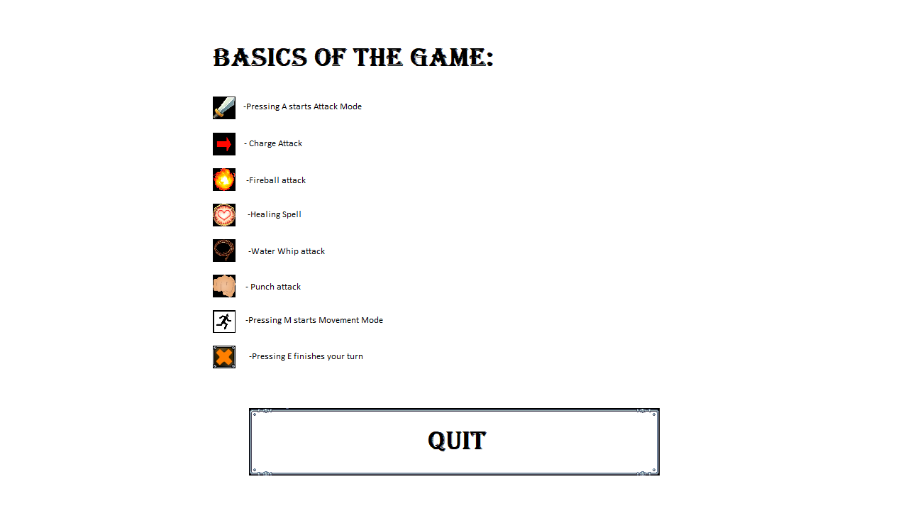

***The How To Play Screen***

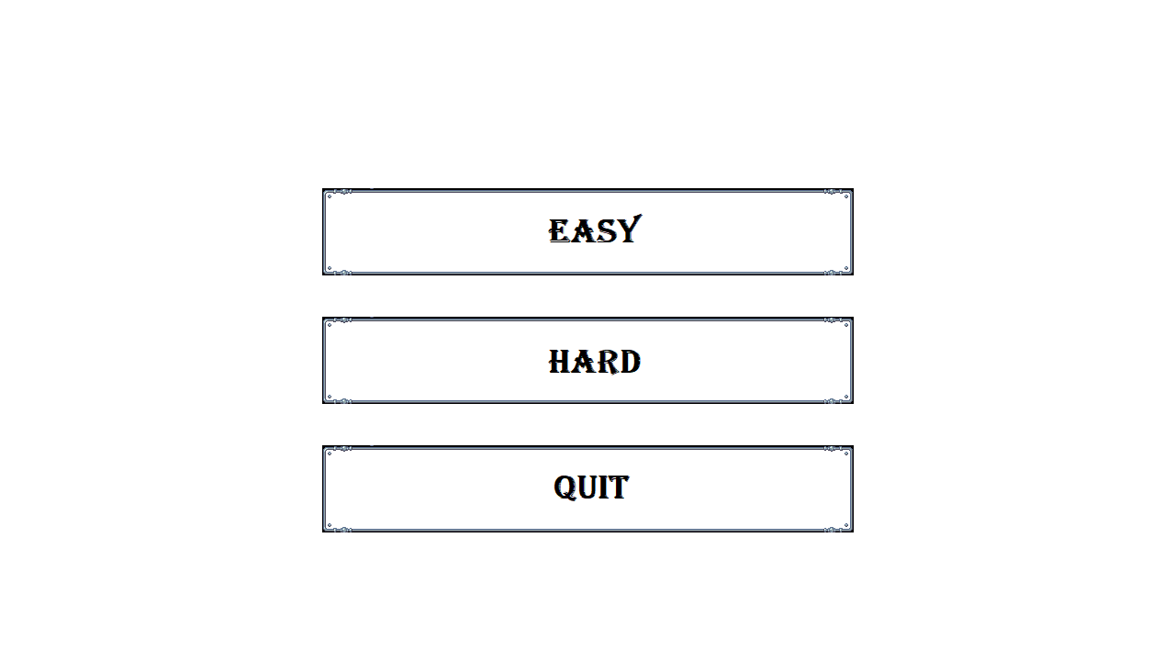

***When you select to play this screen will pop up for you to select difficulty or quit to go back***

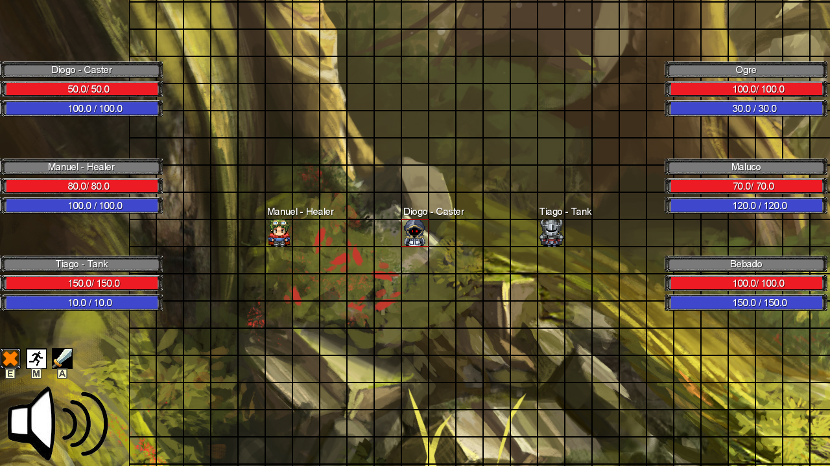

***After that you will see this screen with your character , you can press the speaker icon to mute the music and you can see bars with the name of the units and their current HP and Mana.***

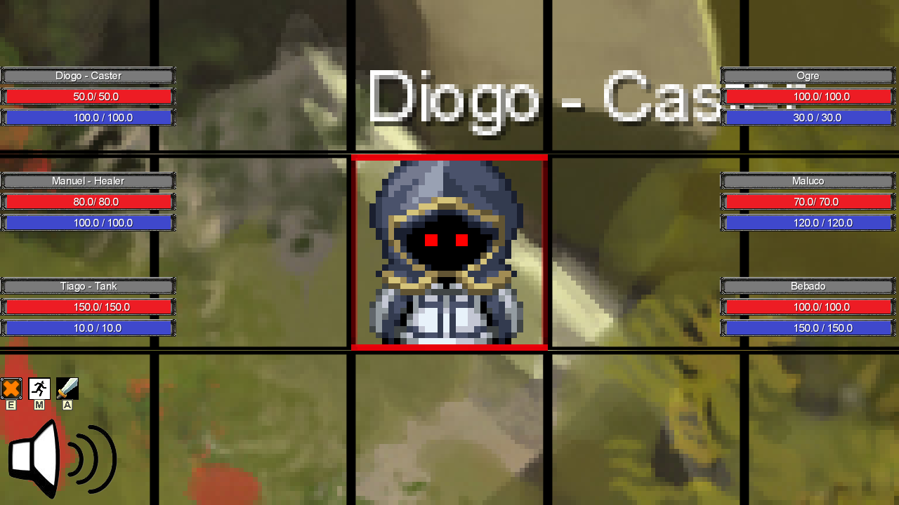

***You can press Page Up To Zoom In***

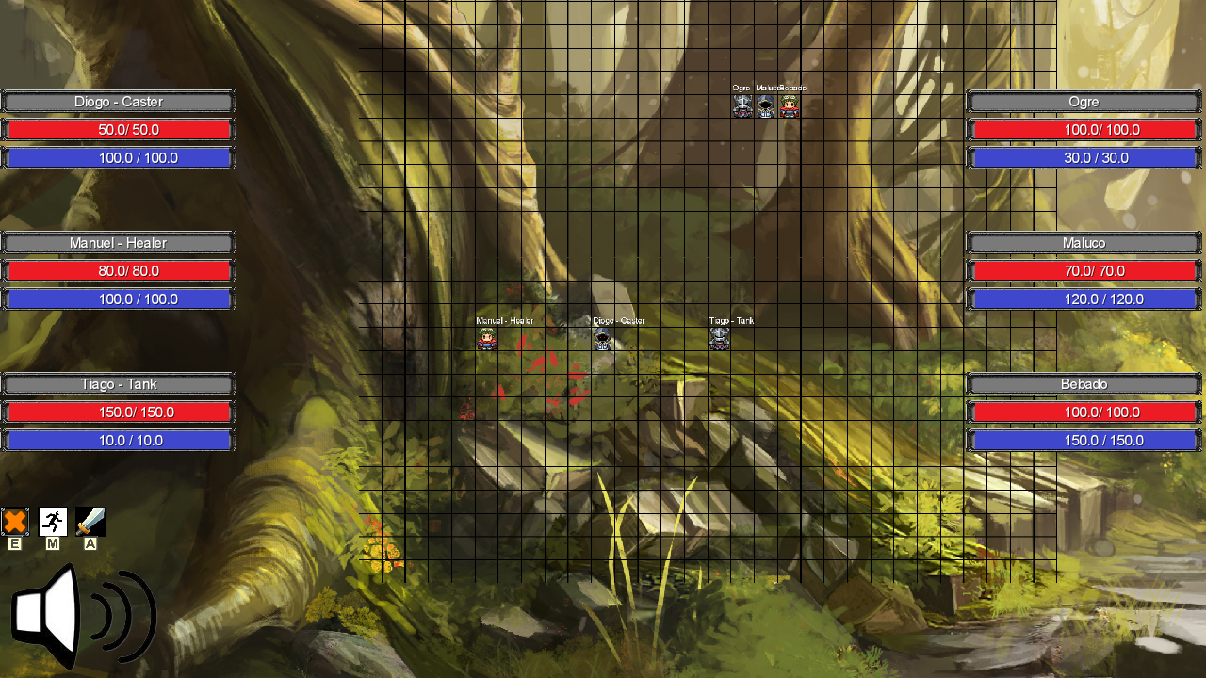

***You can press Page Down to zoom out***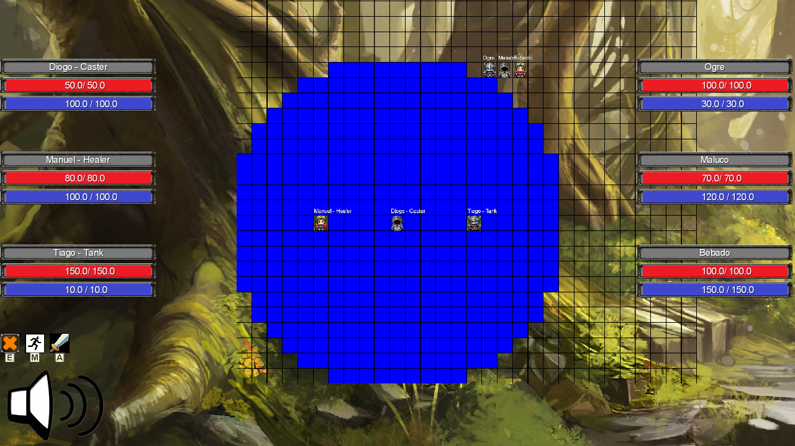

***You can press M to engage movement move then select the cell you want to move to , you can move for as long as you have movements left this turn***

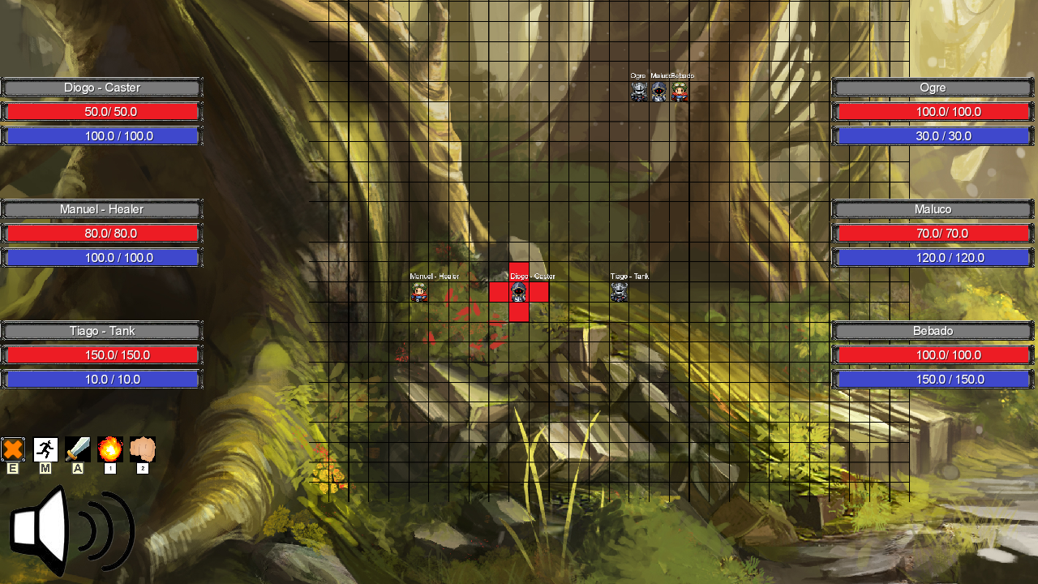

***You can press A to engage attack mode then press 1 or 2 select the ability you want to use here we pressed 2 to select the Punch Ability ; different abilities have different ranges and other attributes; you can then select one of the red cells to attack it if it has a unit in it. You can only attack once per turn***

***You can press E to end this units current turn.***

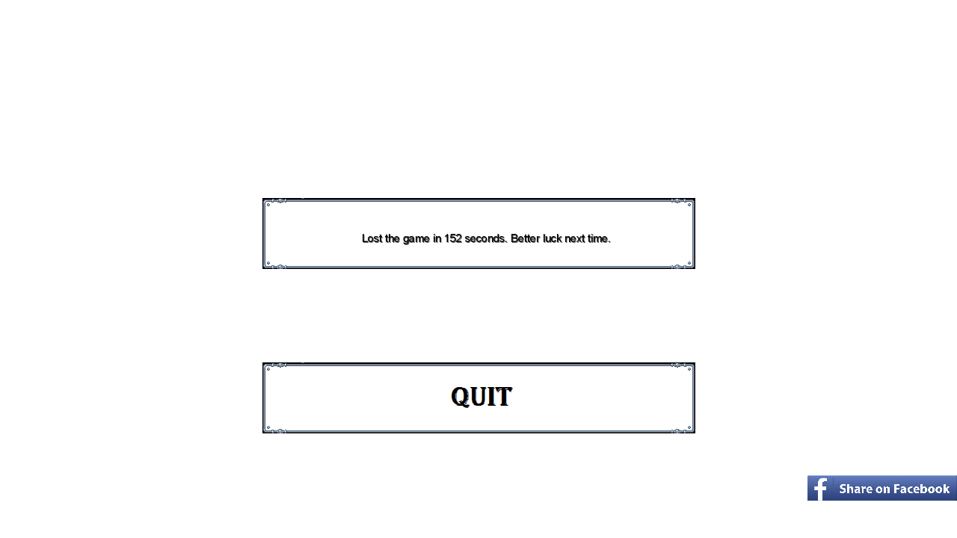

***After you have won or lost you will see a screen telling you that you lost or won and how long it took you , you can then either share that fact on facebook or go back to the main menu with quit.***